Tarea#5 Caballero Nagaya Jesus Adrian

**Cookies**

<https://github.com/JesusCab/LenguajesModernos.git>

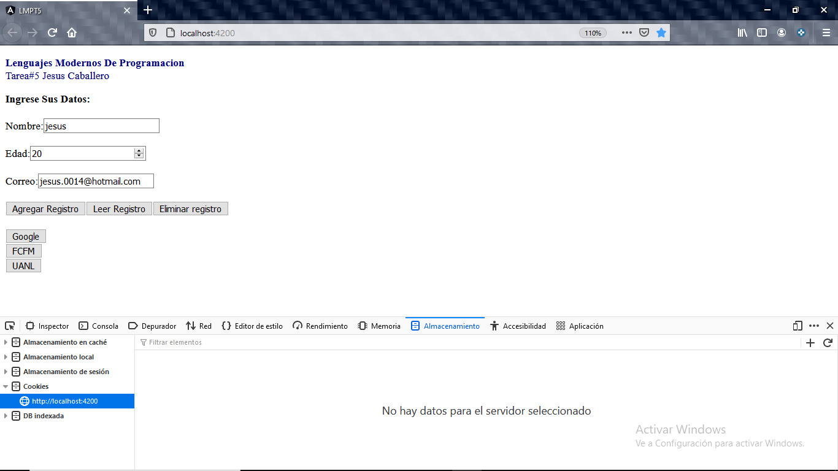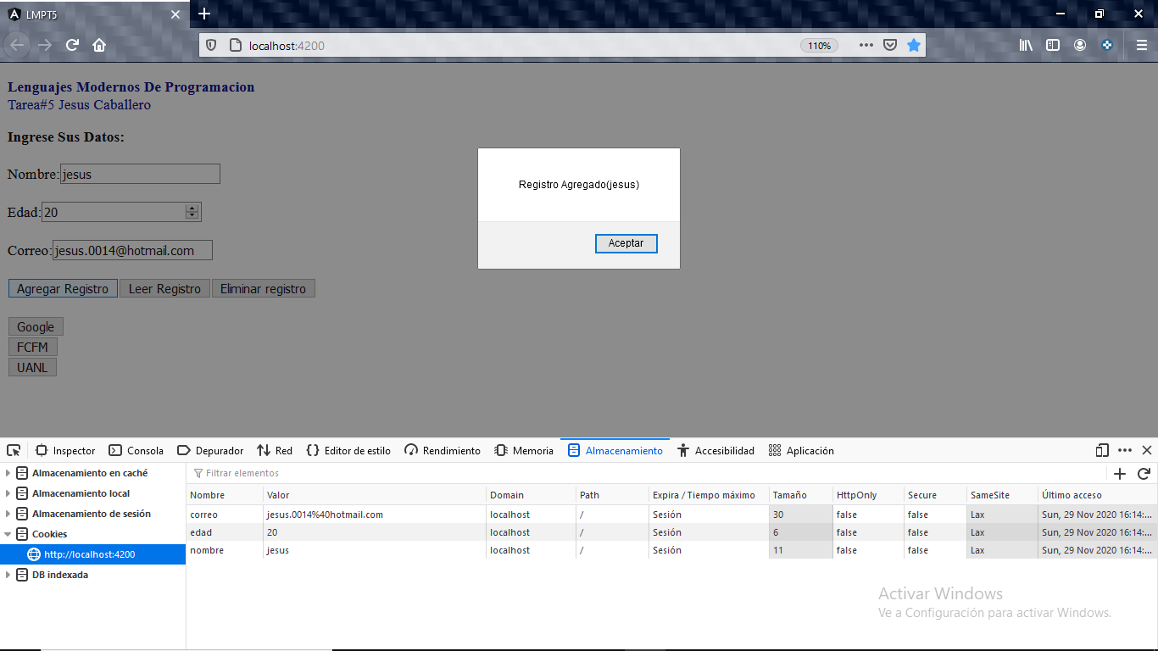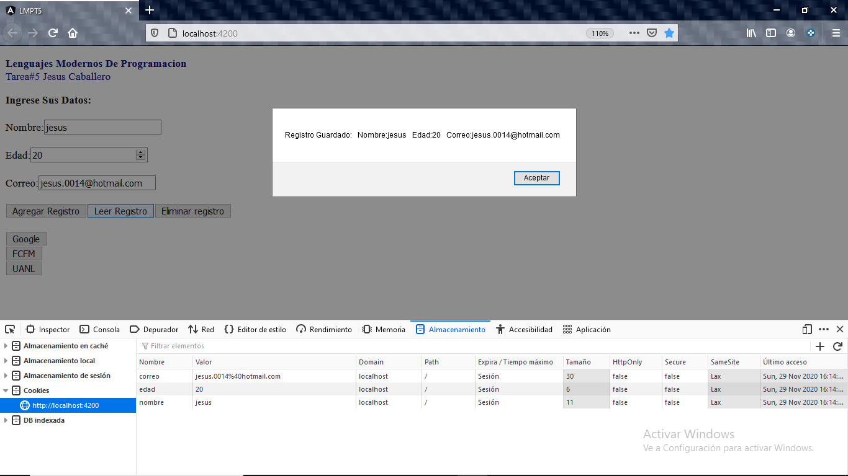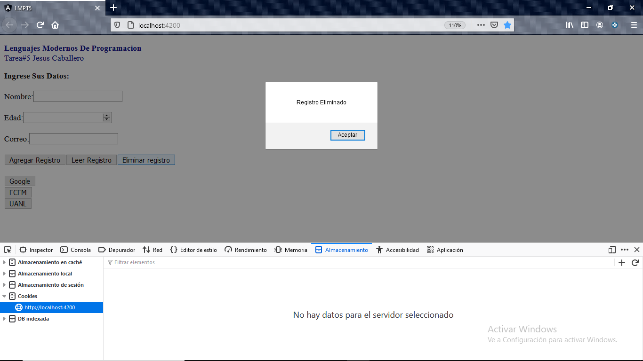

<https://github.com/JesusCab/LenguajesModernos.git>